CENWP-OD-J May 26, 2022

MEMORANDUM FOR THE RECORD

SUBJECT: 22JDA06 MU-1 Temporarily Offline (STS Camera Lodged in Gatewell)

At approximately 1030 on Wednesday May 25th, the JDA STS inspection camera got lodged in gatewell 1A (at a depth of ~70-feet). The crane crew immediately had MU-1 taken offline and contacted fisheries personnel. At this time the gatewell orifice was closed and an ROV was deployed to locate the blockage source. In the northside of the gatewell, personnel noticed a few sticks lodged in the track. The crane crew decided the size of the sticks posed no threat to the camera’s hoist. The hoist was activated, and the sticks broke free.

The blockage was cleared at approximately 1400. At this time MU-1 was brought back online and crews finished STS inspections in gatewells 1B and 1C.

Note: While MU-1 was offline, MU-2 was run in its place per FPP guidelines.

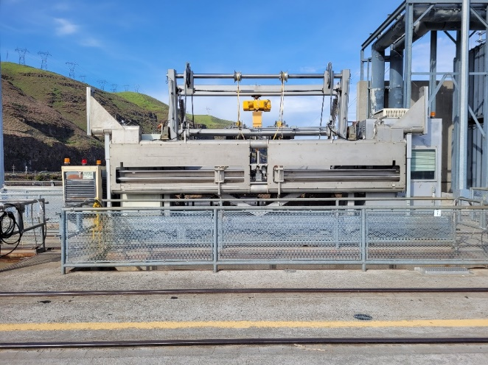
Figure 1: STS inspection camera system

- Species – Potential delayed outmigration for any Chinook, sockeye, steelhead, coho, and/or lampreys in MU-1A gatewell while the orifice was closed (species found in JDA condition monitoring sample for May 25th).
- Origin – Unknown
- Length – Typically smolts (may have been a few adult downstream migrants)
- Marks and tags – Unknown
- Marks and Injuries found on carcass – NA, there were no mortalities observed.
- Cause and Time of Death – NA
- Future and Preventative Measures – Fortunately crews quickly identified the source of the blockage and did not apply excessive force to the hoist until they knew it was safe to do so. To reduce future outage times, crane crews should locate the ROV prior to performing inspections.

Sincerely, Project Fisheries

